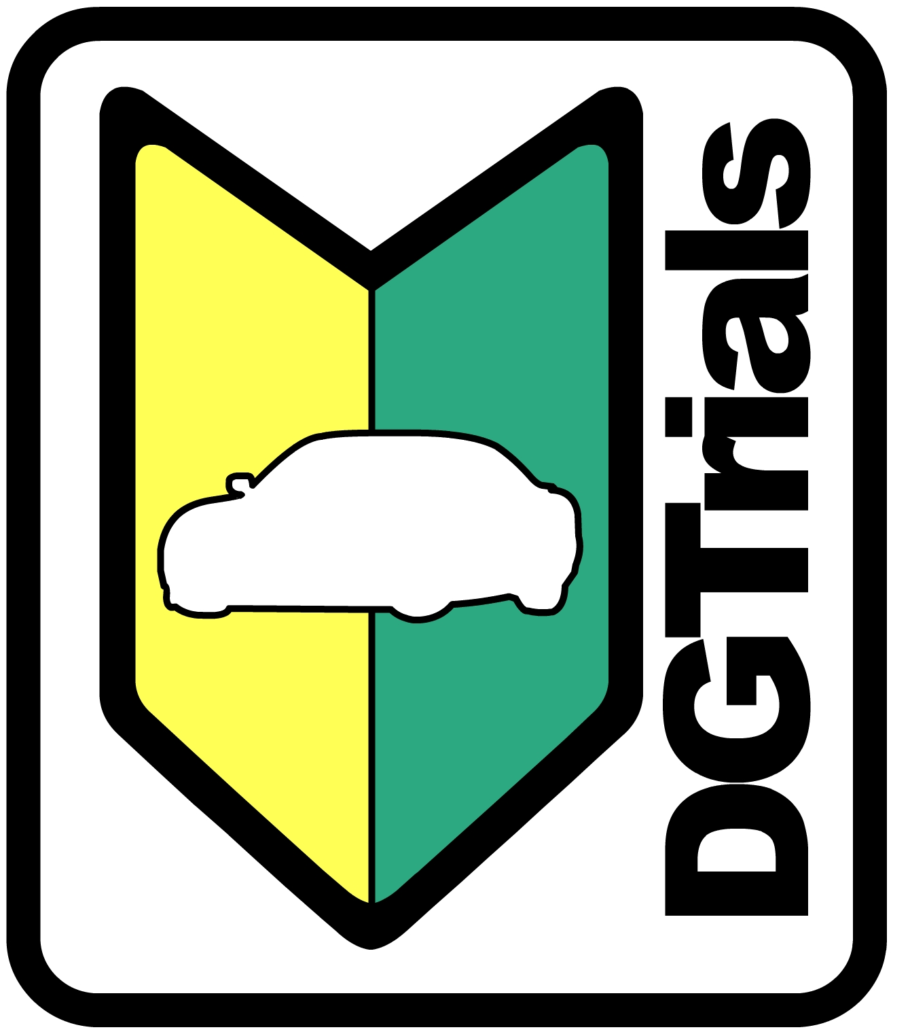
DGTrials Tandem Drifting Petition
This form should be completed in its entirety by those drivers wishing to petition for permission to tandem drift in an advanced time-based group at any and all DGTrials events where such a group is offered. By submitting this petition, a driver acknowledges that they understand all of the risks, both bodily and to their equipment, presented by tandem drifting. DGTrials will make every effort to only accept petitions from drivers of the highest skill and with the greatest experience. However DGTrials will not be held liable for incidents occurring between drivers. Form contents should be submitted to info@DGTrials.com
Driver Contact Information
Name (F): _____________________________

Name (L): _____________________________

Addr (1): ______________________________

Addr (2): ______________________________

Addr (3): ______________________________

City: _________________________________

State: ____ Zip: ________________________

Tel: __________________________________

Vehicle Information
Make: _______________________________

Model: ______________ Year: ___________

Emergency Contact
Name: _______________________________

Tel: _________________________________

Relation: _____________________________
Driver License Information
Number: _____________________________

State: ______________ Exp: ____________

Driving/Racing Experience:
Please provide details on your driving/racing experience, relevant to drifting first. Note any current licenses held (FD, D1, WRC, NASA, etc).

